Broward Middle School Championship Tournament
Saturday, April 27th 8:00am – 4:30pm
Cypress Bay High School

Drops & Changes: SpeechWire will remain open until 7am Saturday, but please make any updates as soon as you know about them.

Parking: Parking will be in gate 3 and 5. Enter the school through the big white gates in the front.

Security: All students must have their school ID on and visible.

Check in: Please arrive at Cypress Bay HS and head to the CAFETERIA between 7:30 – 8:00am to check your teams in. We are starting rounds at 8:15am and if you have students who are late, they risk being dropped from the tournament. Please DO NOT bring students who are not registered. Please understand we will NOT move a student from one category to the other.

Judges: Please make sure all judges have a charged laptop/tablet and have their chargers with them! Check-in will be in the Auditorium, and we will move to Media Center (The Wave) around lunch time. Please double and triple confirm with your judges! We don’t have any extra for Saturday, which means that if any don't show up coaches should be expecting to jump in and judge! Judges should expect to be there the full day.

Tournament Logistics: There will be 5 rounds for Speech and Debate events, excluding Congress which will have 3 rounds and Policy which will have 4 rounds. The top 6 entries in each event will receive a trophy.
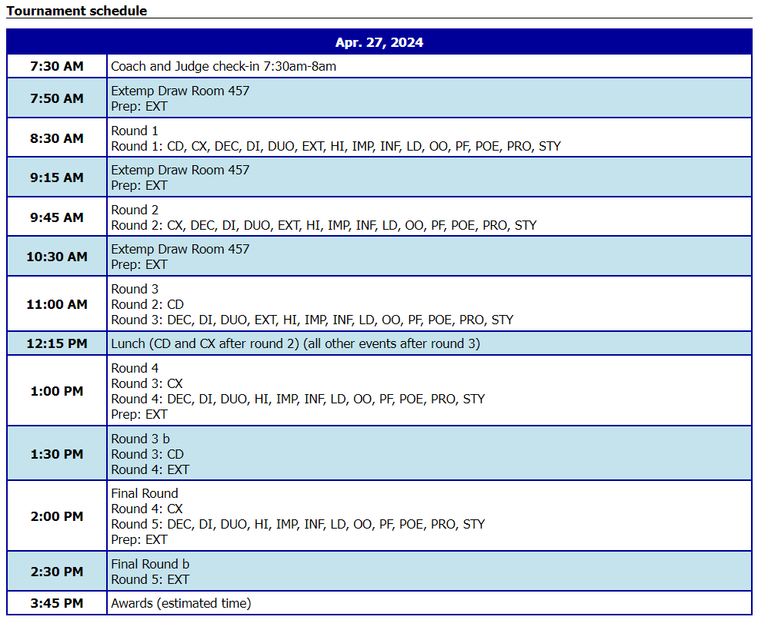
Awards: The awards ceremony will take place in the AUDITORIUM immediately following the conclusion of all rounds. Do not have parents arrive for awards until 3:30pm. They will head to the picnic tables and be escorted into the auditorium when it is time.

Lunch: Please make sure you check the schedule for lunch. Students in Congress and Policy will be eating at different times than the rest, and your Extemp students will be coming in at all different times. Please make sure you save pizza for them. Remember, each pie you order is for 4 students (2 slices and a water each).

Our hosts at Cypress Bay are preparing to do an amazing job welcoming us to their campus! We'll see you bright and early, Saturday, at Cypress Bay HS!

